
UNIVERSITY OF BOLTON
BSc COMPUTING
COURSEWORK SUBMISSION FORM
Student/Centre to complete:

SURNAME/FAMILY NAME: SABIR FORENAMES: NAVEED

BOLTON STUDENT ID: 2224755 EMAIL: ns7crt@bolton.ac.uk

DATE OF SUBMISSION: 08/12/2023

MODULE NO./TITLE: SWE5202 Data Structures and Algorithms

TUTOR’S NAME:………Abdul Razak…………………...... ……………………

COURSEWORK TITLE: Portfolio item 3 Tree Data structures and recursion

Please state if this is your FIRST submission OR REFERRED/DEFERRED submission OR a REPEAT submission?
FIRST

…………………..…………………………………………………………………………………………
Declaration
I hereby declare that this work is my own work. I understand that if I am suspected of plagiarism or another form of cheating, my work be referred to Academic Registrar and/or the Board of Examiners, which may result in me being expelled from the programme. I understand once I submit this work, it will automatically belong to the University of Bolton.

Creative Technologies

Course / Programme: BEng (Hons) in Software Engineering
Module name and code: Data Structures and Algorithms SWE5202
Tutor: Abdul Razak
Assessment Number: 3
Assessment Title: Tree Data structures and recursion
Weighting: 25%
Issue Date: W/C 20 November 2023
Submission Deadline: 08 December 2023 @16:00.

Figure 1 4
Figure 2 4
Figure 3 4
Figure 4 5
Figure 5 5
Figure 6 6
Figure 7 6
Figure 8 6
Figure 9 7
Figure 10 8
Figure 11 8
Figure 12 9
Figure 13 9
Figure 14 9
Figure 15 9
Figure 16 10
Figure 17 10
Figure 18 10
Figure 19 10
Figure 20 11
Figure 21 11
Figure 22 11
Figure 23 12
Figure 24 13
Figure 25 13
Figure 26 13
Figure 27 13
Figure 28 13
Figure 29 14
Figure 30 14
Figure 31 14
Figure 32 15
Figure 33 15
Figure 34 16

Contents
Tree Data structures and recursion 2
STAGE 1 3
STAGE 2 5
STAGE 3 6
STAGE 4 8
STAGE 5 11
UML 14
REFERENCES 15

Tree Data structures and recursion
In computer science and data management, the effort of designing and implementing advanced tree data structures and traversal algorithms is crucial (Thomas H. Cormen et al., 2022). Trees, a basic data structure, are widely utilised in many fields, including database management systems, file systems, and network routing algorithms (Introduction to the Analysis of Algorithms by Robert Sedgewick and Philippe Flajolet. ). The challenge is to create complex tree structures that efficiently arrange and store data while allowing for quick retrieval and change. (J. Á. Velázquez-Iturbide, M. E. Castellanos and R. Hijón-Neira, 2016) Developing optimised traversal algorithms that allow for seamless transit throughout the tree's hierarchical branches is also critical. These efforts significantly increase the efficiency and speed of algorithms, which has a positive influence on the overall performance of software systems and applications that rely on structured data representation. The study and improvement of such complicated tree structures and traversal algorithms will remain critical to the evolution of computing paradigms. (H. P. Zellweger, 2016)

STAGE 1
This code's objective is to define the Employee Java class, which represents an employee and includes basic information such forename, surname, job title, and remuneration. The class has two constructors: one for creating workers with default settings and another for creating employees with specified data (Algorithms, 4th Edition by Robert Sedgewick and Kevin Wayne. ).
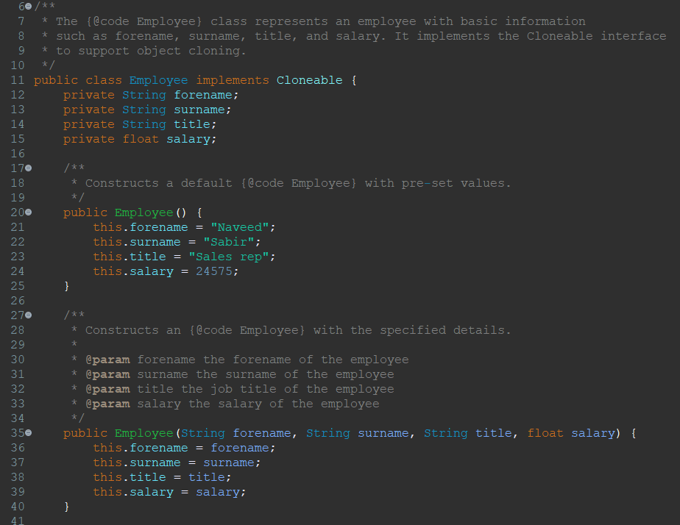
Figure 1
Setter methods are available for changing certain attributes, and getter methods are available for getting the values of these components.
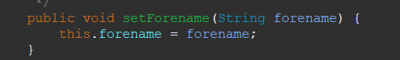
Figure 2
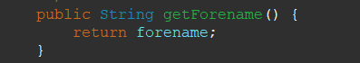
Figure 3
The class implements the Cloneable interface to ease object cloning, allowing the creation of a clone of an existing Employee object. As a result, the clone technique is disabled (Data Structures & Algorithms in Java. ).
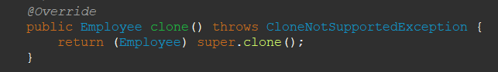
Figure 4
Furthermore, the toString function has been changed to provide a string representation of the Employee object for debugging and logging.
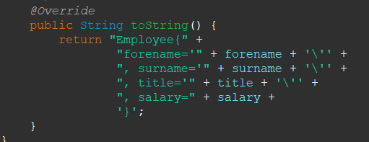
Figure 5

STAGE 2
The goal of the code is to show how to create and display an employee hierarchy in Java Swing using a tree structure provided with DefaultMutableTreeNode (Introduction to Tree - Data Structure and Algorithm Tutorials.2021).
Figure 6
Employee information, such as forename, surname, job title, and remuneration, is stored in the Employee class. The DisplayTest001 class produces employee instances, builds a tree structure by connecting them with DefaultMutableTreeNode objects, and then shows the hierarchy with a recursive method (displayTree).
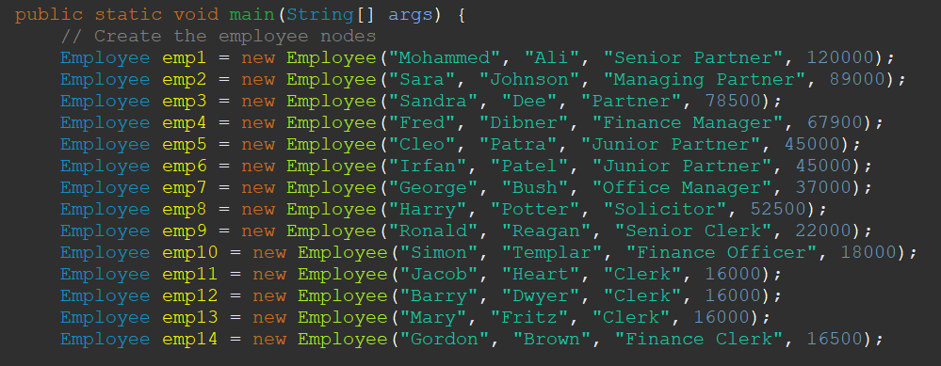
Figure 7
The main function generates tree nodes for each employee, builds the hierarchy by adding child nodes, and then reports the hierarchical structure using the displayTree method.
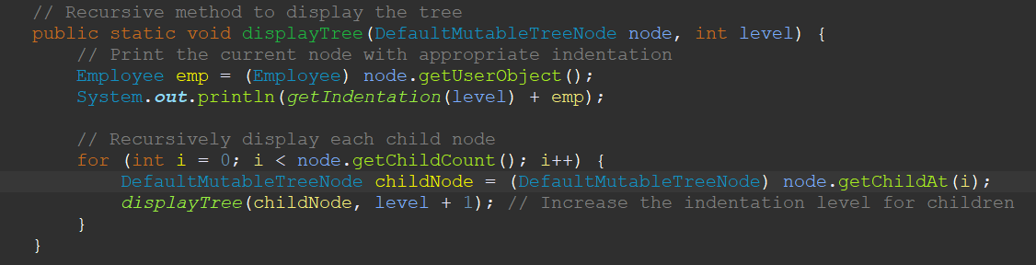
Figure 8
The output visually illustrates the organization's staff hierarchy, emphasising the connections between distinct job positions and their related personnel. The code demonstrates how to use tree structures for hierarchical data representation, which is useful in contexts such as organisational charts and file system topologies.
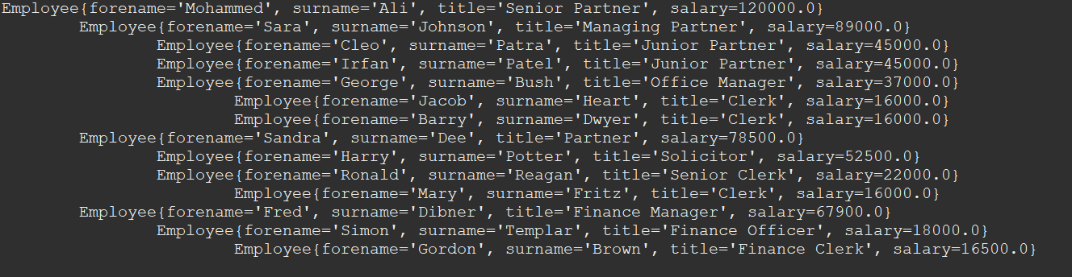
Figure 9

STAGE 3
The goal of the code is to show how to generate and present an employee hierarchy using a tree structure created in Java Swing using DefaultMutableTreeNode. In addition to producing the hierarchy, the DisplayTest002 class has methods for filtering and presenting information about the personnel structure. It specifically covers two techniques: displayHighEarners and displayWithSubordinates (Joshua Bloch, 2018).
The main method generates employee instances, constructs a hierarchical structure with tree nodes, and then demonstrates the capabilities of the other methods.
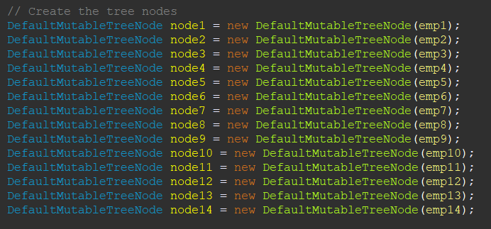
Figure 10
The first approach, displayHighEarners, recursively examines the employee hierarchy and shows information about those earning more than a given threshold (in this case, £50,000).
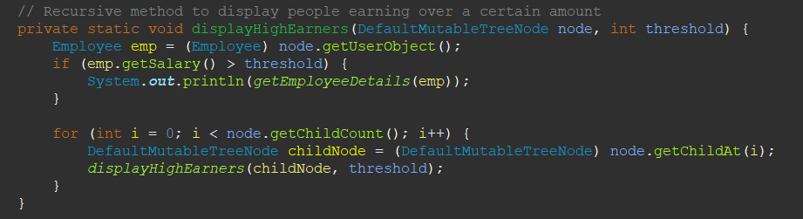
Figure 11
The second approach, displayWithSubordinates, recursively discovers workers with subordinates, publishes their information, and shows the number of direct reports, including subordinate information.
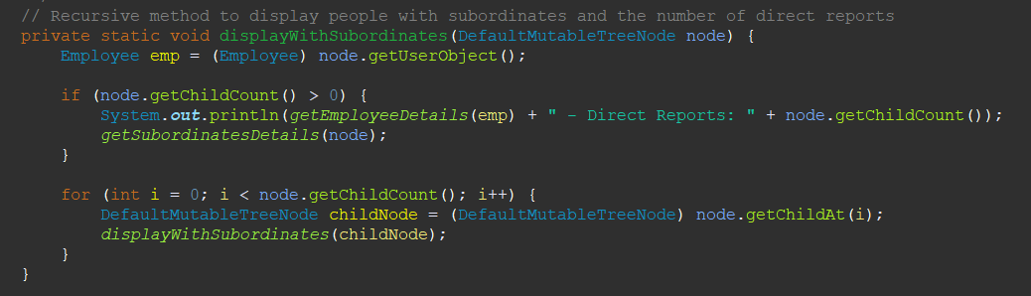
Figure 12
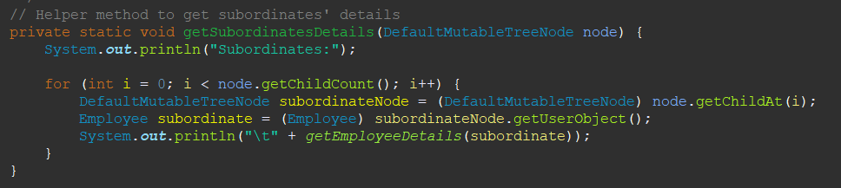
Figure 13
The code is a practical illustration of using tree structures to manage and visualise hierarchical data, exhibiting its adaptability in extracting specific information from the hierarchy. It is especially effective in cases where identifying employees with subordinates or filtering employees based on compensation is crucial, such as in organisational management or reporting systems (How to Use Trees (The Java™ Tutorials > Creating a GUI With Swing > Using Swing Components). ).
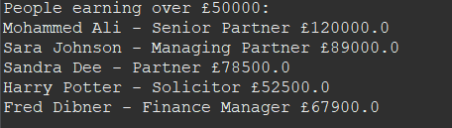
Figure 14
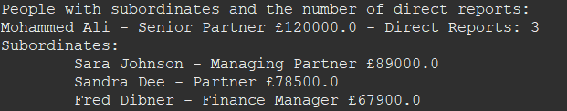
Figure 15

STAGE 4
The purpose of the code in DisplayTest003 is to create and display a graphical representation of an employee hierarchy using Java Swing components, specifically JTree and JFrame. Here's an overview of the key functionality (Trail: Creating a GUI With Swing (The Java™ Tutorials)):
- Tree Model and JTree Creation:
  - The code creates a DefaultTreeModel named treeModel with the root node representing the top-level employee in the hierarchy.
Figure 16
  - A JTree named tree is instantiated using the created DefaultTreeModel. The JTree is a Swing component designed for displaying hierarchical data in tree structures.
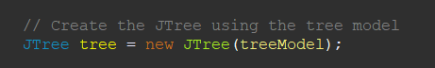
Figure 17

- JFrame Setup:
  - A JFrame named frame is created with the title "Employee Hierarchy."
  - The JFrame is configured to exit the application when the close button is clicked (JFrame.EXIT_ON_CLOSE).
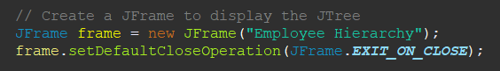
Figure 18

- Adding JTree to JFrame:
  - The JTree is embedded in a JScrollPane to allow scrolling if the hierarchy exceeds the visible area.
  - The JScrollPane is added to the content pane of the JFrame.
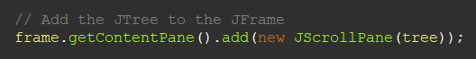
Figure 19

- Employee Data and Tree Structure:
  - Employee instances are created, each representing a node in the hierarchy. These instances include information such as forename, surname, job title, and salary.
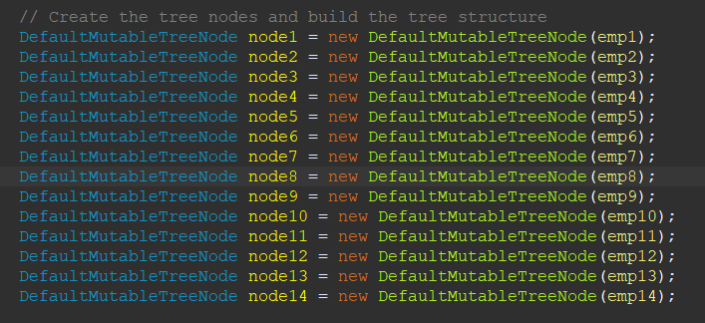
Figure 20
  - DefaultMutableTreeNode objects are created for each employee, and the hierarchy is built by adding child nodes to represent reporting relationships within the organization.
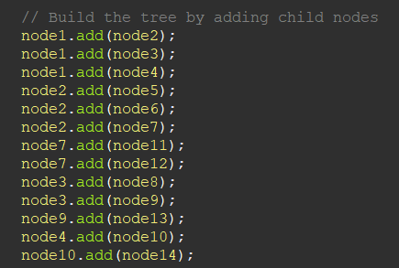
Figure 21
- Display:
  - The JTree is displayed within the JFrame, providing a visual representation of the employee hierarchy.
  - The JFrame is set to a size of 400x600 pixels and is positioned at the centre of the screen.
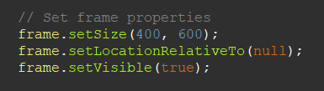
Figure 22
  - The JFrame is set to be visible, making the employee hierarchy represented by the JTree visible to the user.
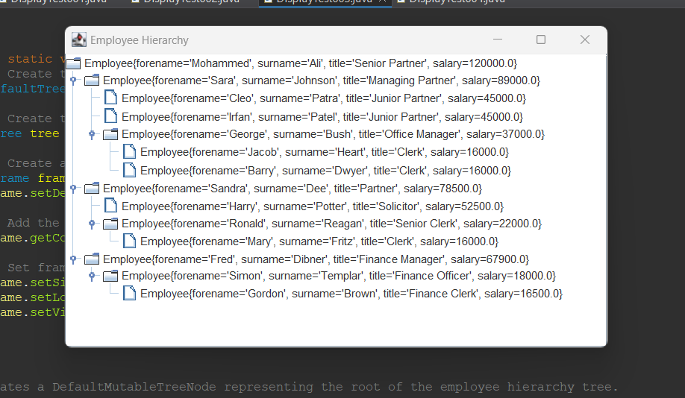
Figure 23

Overall, the code demonstrates how to use Java Swing components to produce a rudimentary graphical representation of hierarchical data. In this example, the approach is used to depict an organisational people hierarchy, but it may be used to other situations where tree topologies are useful for data visualisation. (J. P. Vieira Costa et al., 2022)

STAGE 5
The provided code is a Java program that demonstrates the creation and manipulation of an employee hierarchy using a tree structure implemented with DefaultMutableTreeNode and JTree. Here's a brief explanation of the code:
- Class Overview:
  - DisplayTest004: This class serves as the main class for the application.
- Main Method (public static void main(String[] args)):
  - Creates a DefaultTreeModel with the root node representing the initial employee hierarchy.
Figure 24
  - Creates a JTree using the tree model.
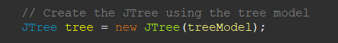
Figure 25
  - Adds new nodes to the tree model using the addNewNodes method.
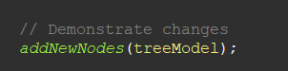
Figure 26
  - Updates the hierarchy based on the specified criteria using the updateHierarchy method.
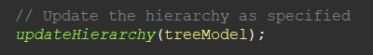
Figure 27
  - Displays the employee hierarchy in a JFrame using a JTree.
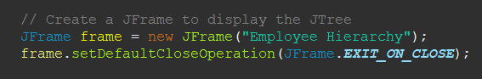
Figure 28
- Create Employee Tree Method (private static DefaultMutableTreeNode createEmployeeTree())):
  - Creates a tree structure representing an initial employee hierarchy with various employees and their roles.
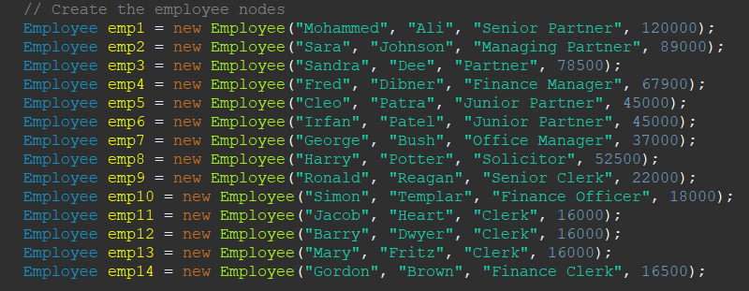
Figure 29
- Add New Nodes Method (private static void addNewNodes(DefaultTreeModel treeModel)):
  - Adds new employee nodes to the existing tree model.
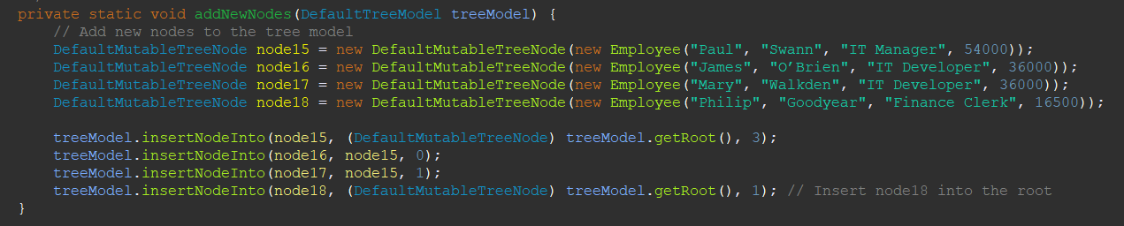
Figure 30
- Update Hierarchy Method (private static void updateHierarchy(DefaultTreeModel treeModel)):
  - Updates the hierarchy as specified in the code. In this case, it relocates the subordinates of "Node 7" to report to "Node 5" and removes "Node 7."
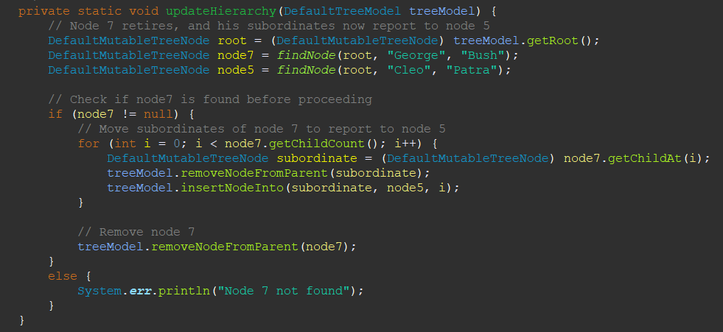
Figure 31
- Find Node Method (private static DefaultMutableTreeNode findNode(DefaultMutableTreeNode root, String forename, String surname)):
  - Finds a node with a specific forename and surname in the employee hierarchy tree.
  - Calls the recursive method findNodeRecursively to perform the search.
Figure 32
- Find Node Recursively Method (private static DefaultMutableTreeNode findNodeRecursively(DefaultMutableTreeNode currentNode, String forename, String surname)):
  - Recursively searches for a node with a specific forename and surname in the employee hierarchy tree.
  - Returns the node if found; otherwise, returns null.
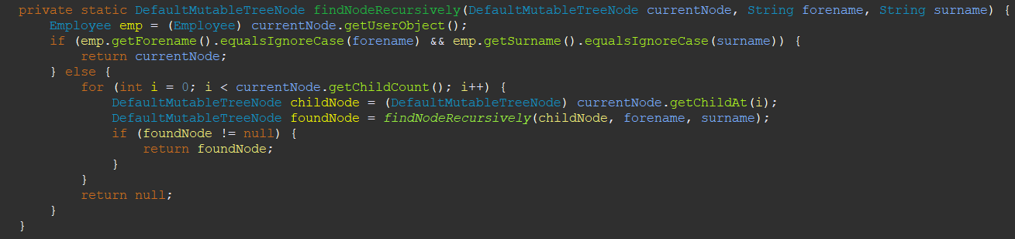
Figure 33
The goal of this code is to demonstrate how to construct, manipulate, and display an employee hierarchy in a Java Swing application using a tree structure. It shows how to add new nodes and update the hierarchy, demonstrating the versatility of the DefaultMutableTreeNode and JTree classes in maintaining hierarchical data. (A. Al-Rawi, A. Lansari and F. Bouslama, 2003)

UML

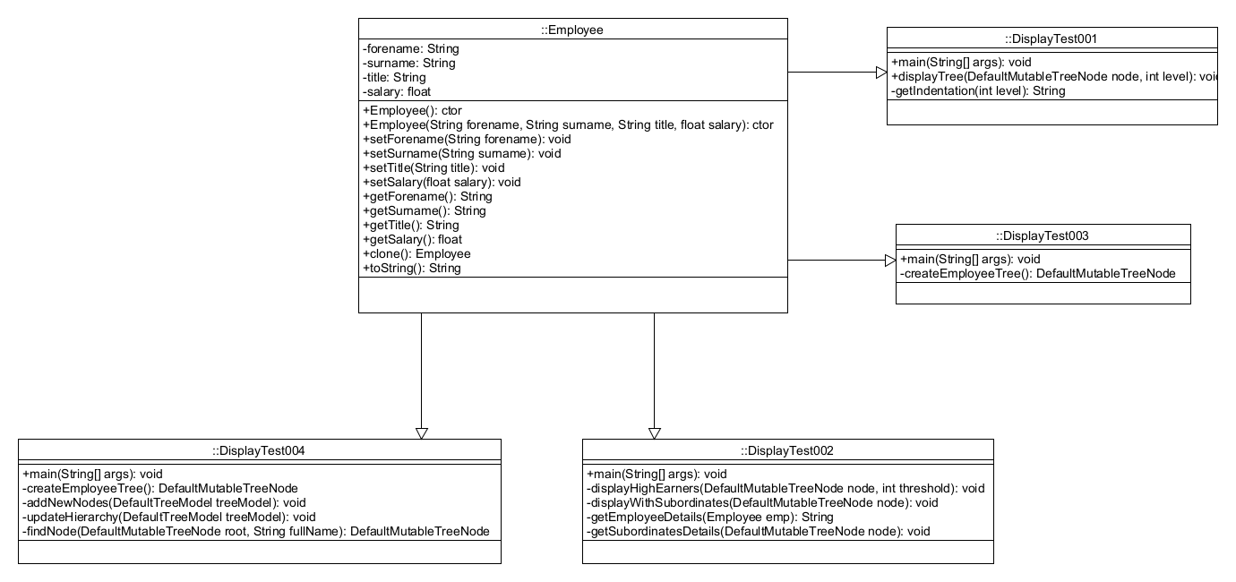
Figure 34

REFERENCES

H. P. Zellweger (2016) Tree Visualizations in Structured Data Recursively Defined by the Aleph Data Relation. In:2016 20th International Conference Information Visualisation (IV) . , [Online] Available from: . [Accessed].

J. Á. Velázquez-Iturbide, M. E. Castellanos and R. Hijón-Neira (2016) Recursion Removal as an Instructional Method to Enhance the Understanding of Recursion Tracing. IEEE Transactions on Education, [Online] 59 (3), pp. 161-168 Available from: . [Accessed].

A. Al-Rawi, A. Lansari and F. Bouslama (2003) A new non-recursive algorithm for binary search tree traversal. In:10th IEEE International Conference on Electronics, Circuits and Systems, 2003. ICECS 2003. Proceedings of the 2003 . , [Online] Available from: . [Accessed].

J. P. Vieira Costa, C. Atreio Portela, H. Kimura, M. Ladeira and F. Barros Diniz (2022) Lifetime Probability of Default using Survival Tree-Based Models. In:2022 17th Iberian Conference on Information Systems and Technologies (CISTI) . , [Online] Available from: . [Accessed].
Trail: Creating a GUI With Swing (The Java™ Tutorials). ( ) , [Online] ( ), pp. Available from: https://docs.oracle.com/javase/tutorial/uiswing/. [Accessed].
How to Use Trees (The Java™ Tutorials > Creating a GUI With Swing > Using Swing Components). ( ) , [Online] ( ), pp. Available from: https://docs.oracle.com/javase/tutorial/uiswing/components/tree.html. [Accessed].
Data Structures & Algorithms in Java. ( ) , [Online] ( ), pp. Available from: https://everythingcomputerscience.com/books/schoolboek-data_structures_and_algorithms_in_java.pdf. [Accessed].
Introduction to the Analysis of Algorithms by Robert Sedgewick and Philippe Flajolet. ( ) , [Online] ( ), pp. Available from: https://aofa.cs.princeton.edu/home/. [Accessed].
Algorithms, 4th Edition by Robert Sedgewick and Kevin Wayne. ( ) , [Online] ( ), pp. Available from: https://algs4.cs.princeton.edu/home/. [Accessed].
Joshua Bloch (2018) Effective Java
Third Edition. Third Edition ed. [Online] : . Available from: https://kea.nu/files/textbooks/new/Effective%20Java%20%282017%2C%20Addison-Wesley%29.pdf. [Accessed].
Thomas H. Cormen, Charles E. Leiserson, Ronald L. Rivest and Clifford Stein (2022) Introduction to Algorithms
Fourth Edition. ed. [Online] : . Available from: https://dl.ebooksworld.ir/books/Introduction.to.Algorithms.4th.Leiserson.Stein.Rivest.Cormen.MIT.Press.9780262046305.EBooksWorld.ir.pdf. [Accessed].
Introduction to Tree - Data Structure and Algorithm Tutorials. (2021) ed. [Online] : .Available from: https://www.geeksforgeeks.org/introduction-to-tree-data-structure-and-algorithm-tutorials/. [Accessed].

In this assessment I have achieved the following objectives.
Tick appropriate box  NA – not attempted : Part – part completed : Full - fully completed |  | NA | Part | Full
Stage 1 – | Employee class created with shallow copying |  |  | x
Stage 2 – | Used recursion to display employees |  |  | x
Stage 3 – | Used recursion to display employees earning over a certain salary  Used recursion to display supervisors and the number of employees working directly for them |  |  | x
Stage 4 – | Display the model as a JTree |  |  | x
Stage 5 – | Modify the tree contents as required |  |  | x

